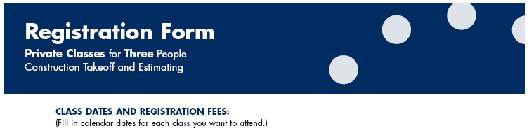
____________________________ PLAN READING – Beginner Level
(Fill in ONE date) One Day for $1,400.00

__________________________________ TAKEOFF – Beginner Level
(Fill in TWO dates) Two Days for $2,800.00

__________________________________ ESTIMATING – Beginner Level
(Fill in TWO dates) Two Days for $2,800.00

__________________________________ TAKEOFF AND ESTIMATING – Intermediate Level
(Fill in THREE dates) Three Days for $4,200.00

__________________________________ TAKEOFF AND ESTIMATING – Advanced Level
(Fill in TWO dates) Two Days for $2,800.00
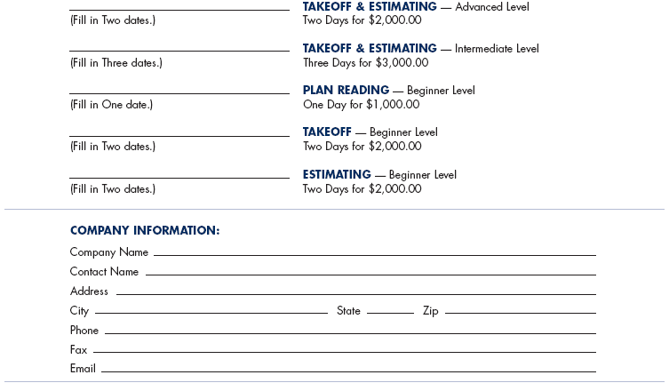

Company Name ___________________________________________________________________
Contact Name _____________________________________________________________________
Address __________________________________________________________________________
City _______________________________________ State ________ Zip ______________________
Phone ____________________________________________________________________________
Fax ______________________________________________________________________________
Email _____________________________________________________________________________

PAYMENT:

Make check or money order payable to
Data Management Institute, LLC and mail to:
Data Management Institute, LLC
1933 Sprucewood Court
Naperville, IL 60565

Note: Please contact us to verify availability of class dates.
Payment must be received with this form to confirm registration.
