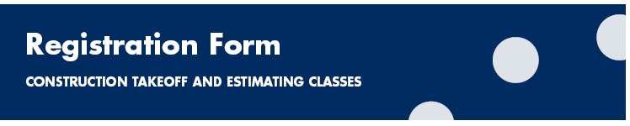
2017 SPECIAL EVENT: THREE-DAY SMALL-GROUP COURSE

TIMES, DATES, AND REGISTRATION FEE:

Daily Class Times 9:30 AM – 4:30 PM
(Time off for lunch)

February 6th PLAN READING

February 7th TAKEOFF

February 8th ESTIMATING

Registration Fee Option A (ALL THREE DAYS) $1,500.00

Registration Fee Option B (ONLY 2nd and 3rd DAYS) $1,000.00

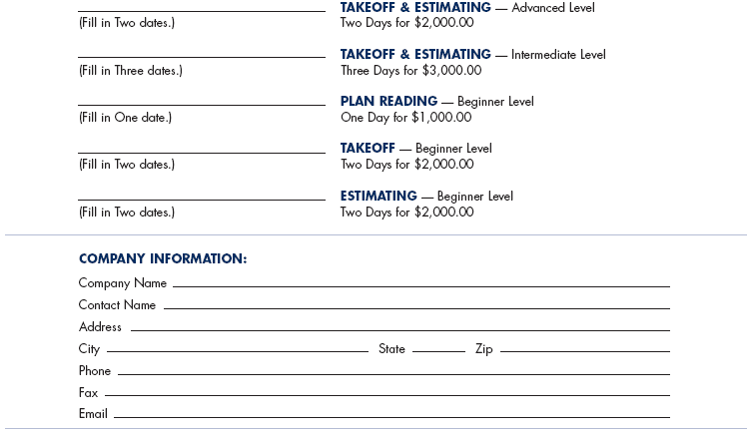

Company Name ___________________________________________________________________
Contact Name _____________________________________________________________________
Address __________________________________________________________________________
City _______________________________________ State ________ Zip ______________________
Phone ____________________________________________________________________________
Fax ______________________________________________________________________________
Email _____________________________________________________________________________

PAYMENT:

Make check or money order payable to
Data Management Institute, LLC and mail to:
Data Management Institute, LLC
1933 Sprucewood Court
Naperville, IL 60565

Note: Please contact us to verify availability of class dates.
Payment must be received with this form to confirm registration.
